Market Monitor - Democratic Republic of the Congo - 2026-05

Highlights
In May 2026, markets in the Democratic Republic of the Congo experienced significant volatility, with sharp price increases in some essential commodities contrasting with a general deflationary trend. Despite a surge in maize and palm oil prices, the overall cost of the food basket declined.
The cost of the national food basket decreased by 8.8% month-on-month (MoM) and 17.1% year-on-year (YoY). The most significant price changes were observed for maize grain (↑69.0% MoM), palm oil (↑21.1% MoM), and wheat flour (↓18.7% MoM).
Key market drivers this month include:
- Hyperinflation in maize grain: The price of raw maize surged by 69.0% in a single month, indicating severe pressure on this core staple.
- Sharp increase in palm oil prices: The cost of palm oil rose significantly by 21.1% MoM, adding to household expenditure pressures.
- Widespread deflation in other staples: Significant price drops for commodities like wheat flour (↓18.7% MoM), beans (↓16.5% MoM), and imported rice (↓7.3% MoM) offset the inflationary spikes and drove the overall food basket cost down.
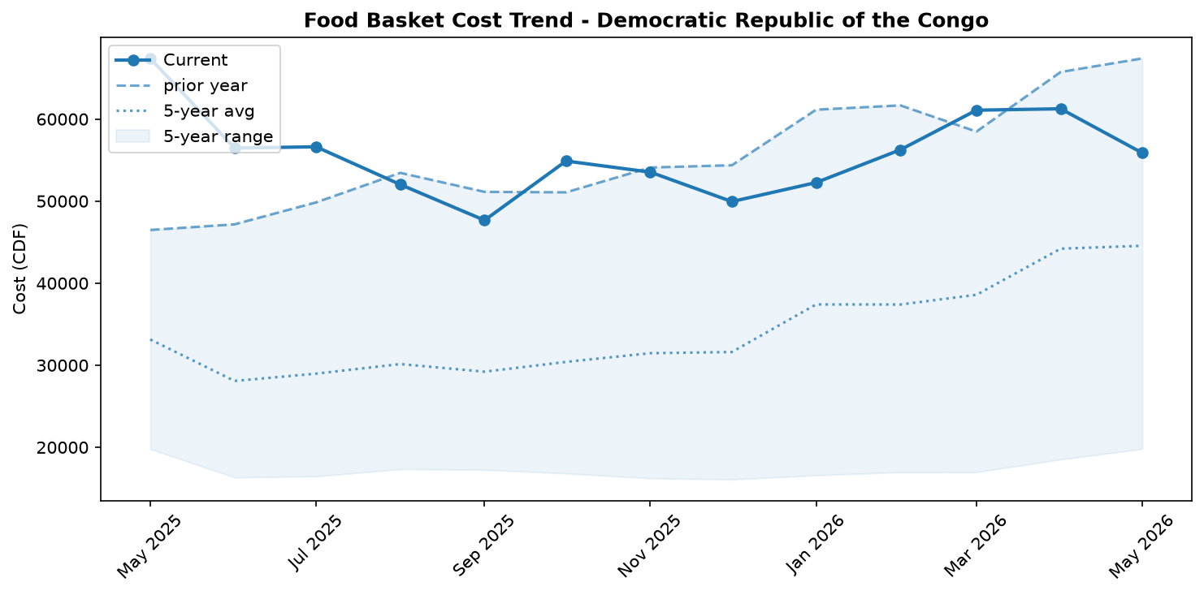
Food basket cost trend

Market Overview
The Democratic Republic of the Congo's markets exhibited extreme volatility in May 2026. While the national average price of the food basket registered a significant month-on-month decrease of 8.8%, this top-line figure conceals alarming and contradictory underlying trends. The overall deflation was driven by substantial price drops in key staples, including beans (-16.5%), wheat flour (-18.7%), and imported rice (-7.3%). This easing of prices for some goods may be partially linked to a slight monthly appreciation of the Congolese Franc (CDF) against the US dollar. However, these decreases were offset by severe inflationary shocks in other essential commodities. The price of raw maize grain experienced hyperinflation, surging by an unprecedented 69.0% in a single month, while palm oil prices also rose sharply by 21.1%. These dramatic increases are strong indicators of acute supply chain disruptions, likely linked to escalating insecurity and a public health emergency in the eastern provinces. The outlook is precarious, as the hyperinflation in raw materials is expected to be passed on to consumers, threatening to reverse recent price decreases and drive up the overall cost of food in the coming months.

Commodity Analysis
May's commodity price movements were characterized by a stark divergence between processed staples and raw or locally sourced goods. A deflationary trend was observed across several key food items. The price of beans fell substantially by 16.5%, while wheat flour and imported rice also saw significant decreases of 18.7% and 7.3%, respectively. Processed maize flour prices also declined by 3.1% month-on-month, contributing to a large 24.6% year-on-year price reduction. Similarly, cassava flour prices decreased moderately by 5.8% from April, though they remain 5.3% higher than a year ago.
In sharp contrast, two commodities experienced severe price shocks. Palm oil was a major outlier, with its price surging by 21.1% in the last month alone. Even more alarming was the hyperinflation in raw maize grain, which skyrocketed by 69.0% month-on-month. This dramatic spike for the raw grain, occurring simultaneously with a price decrease for processed maize flour, points to a severe and recent disruption in the upstream supply chain. This suggests that millers and traders have not yet passed on the full cost increase to consumers, creating a high risk of a sharp price correction for maize flour in the near future. The surge in both maize grain and palm oil likely reflects significant logistical bottlenecks and production challenges, particularly in the country's volatile eastern regions.
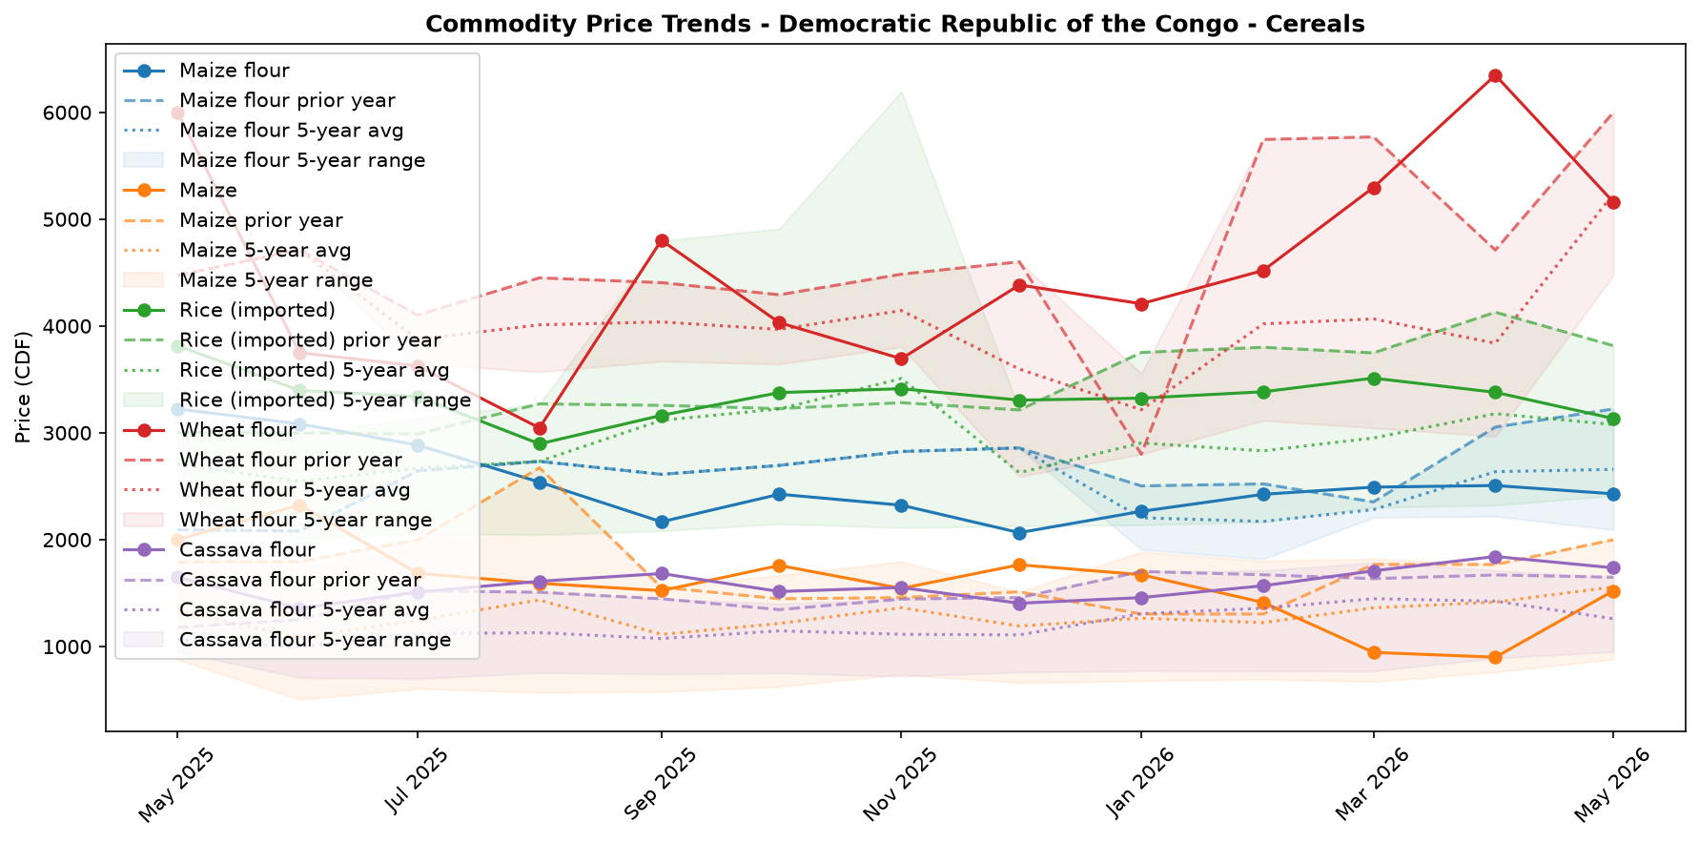
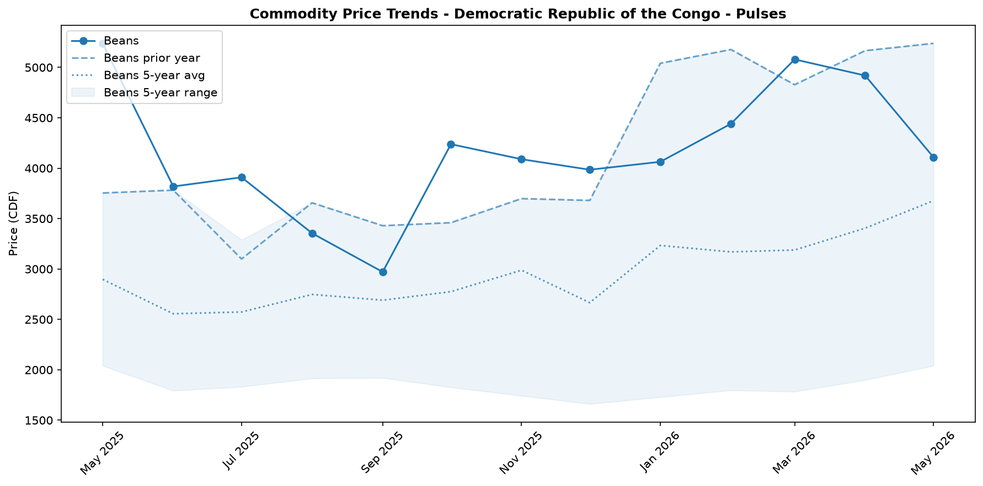

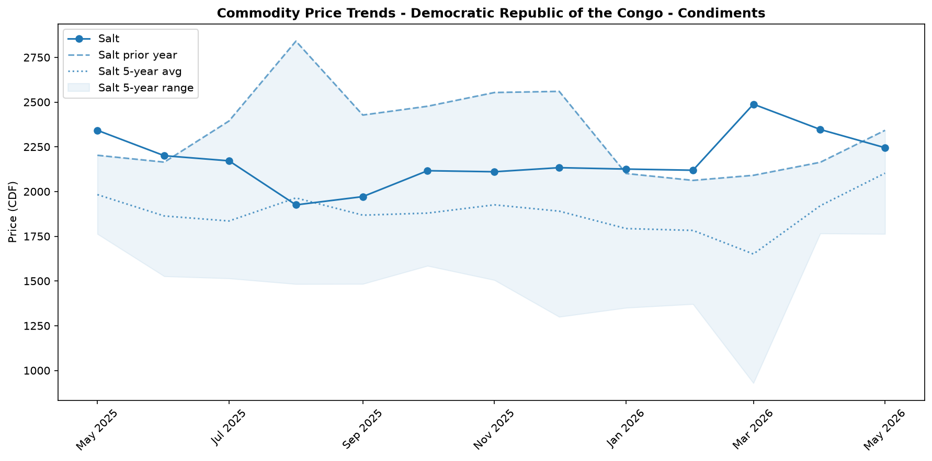

Regional Highlights
While national-level price data is not disaggregated by region, contextual reports strongly indicate that market disruptions are most severe in the eastern provinces of Ituri, North Kivu, and South Kivu. These regions are contending with a convergence of crises that are crippling supply chains and restricting trade. In May, the World Health Organization declared the Bundibugyo virus disease (BVD) outbreak a Public Health Emergency of International Concern, leading to advised travel and trade restrictions that impact the entire country but are centered on the outbreak zone. Compounding this, acute insecurity, armed conflict, and massive internal displacement are severely hampering both humanitarian response and the general movement of goods and people. The extreme price volatility observed nationally for commodities like maize grain (+69.0%) and palm oil (+21.1%) is likely a direct consequence of these localized disruptions impacting production and transport. Despite a recent index suggesting a 'moderately stable but fragile' environment in Ituri, the combination of conflict and public health emergencies continues to exert immense pressure on market functionality in the east.
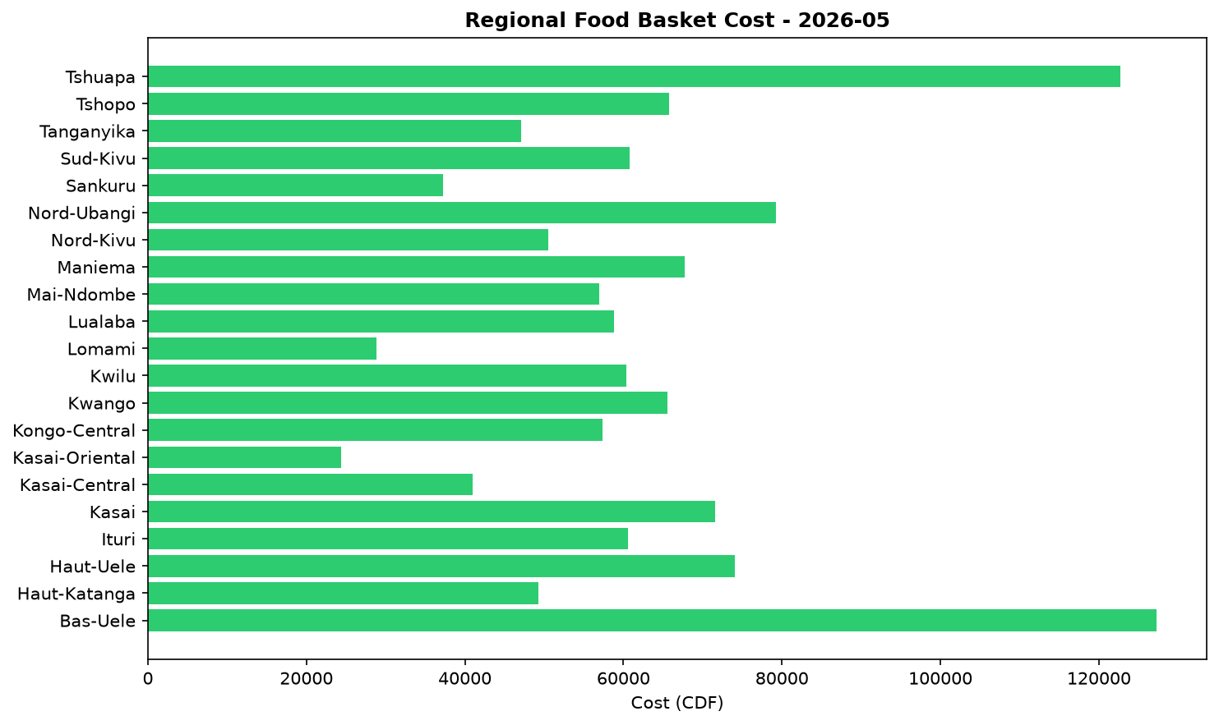

EXCHANGE_RATE Analysis
The Congolese Franc (CDF) has recently shown signs of appreciation, trading at an average of 2307.0 per USD. This represents a slight month-on-month strengthening of 0.94 percent, which could help ease the cost of imported goods. However, this short-term gain is set against a significant long-term depreciation. On a year-on-year basis, the CDF has weakened by 20.57 percent, highlighting sustained pressure on the currency over the past twelve months. This substantial annual depreciation continues to exert upward pressure on the prices of key imported commodities, including wheat, rice, cooking oil, and fuel. While the recent monthly appreciation offers a slight reprieve, the overall weaker currency remains a primary driver of food price inflation, eroding the purchasing power of vulnerable households who rely on these imported staples.

References
- [rw_4214178] ReliefWeb (2026-05-31) IOM: Multi-Country Ebola Bundibugyo Outbreak Situation Report No. 2 (22 - 27 May 2026)
https://reliefweb.int/node/4214178
- [rw_4214159] ReliefWeb (2026-05-30) The metric of life and death: How local and technical experts are strengthening mortality measurement in Eastern DRC
https://reliefweb.int/node/4214159
- [rw_4214140] ReliefWeb (2026-05-29) Disease Outbreak News: Ebola disease caused by Bundibugyo virus - Democratic Republic of the Congo & Uganda (29 May 2026)
https://reliefweb.int/node/4214140
- [rw_4214053] ReliefWeb (2026-05-29) Democratic Republic of the Congo - Ituri Province: Solutions and Mobility Index | Cross-Border Stability Assessment (April 2026)
https://reliefweb.int/node/4214053
- [rw_4214043] ReliefWeb (2026-05-29) UNFPA Flash Update - Bundibugyo Ebola Virus Disease (BVD) Outbreak (20 - 26 May 2026)
https://reliefweb.int/node/4214043
- [rw_4214032] ReliefWeb (2026-05-29) Response to Ebola Outbreak in Democratic Republic of Congo (DRC) and Uganda
https://reliefweb.int/node/4214032
- [rw_4214019] ReliefWeb (2026-05-28) DRC Logistics and Telecommunications Cluster - Standard Operating Procedures (SOPs) for Common Logistics Services, May 2026
https://reliefweb.int/node/4214019
- [rw_4214005] ReliefWeb (2026-05-28) UNICEF’s first international shipment of emergency Ebola response supplies arrives in Ituri, northeastern Democratic Republic of the Congo
https://reliefweb.int/node/4214005
- [rw_4213975] ReliefWeb (2026-05-28) Message by the WHO Director-General to the people of the Democratic Republic of the Congo
https://reliefweb.int/node/4213975
- [rw_4213814] ReliefWeb (2026-05-27) DRC: One in four confirmed Ebola deaths are children underscoring the urgent need to protect them
https://reliefweb.int/node/4213814
- [seerist_1028756] Seerist (2026-05-28) Big Picture series: Ebola outbreak prompts increased travel monitoring, targeted entry restrictions
- [seerist_1028721] Seerist (2026-05-27) Big Picture series: Carbon markets in Sub-Saharan Africa – growing opportunities amid regulatory, integrity challenges
- [seerist_1028614] Seerist (2026-05-20) US-Congo strategic partnership to advance peace deal enforcement, but challenges to critical minerals output will remain
- [seerist_1028608] Seerist (2026-05-19) Ebola outbreak highlights response weaknesses amid fragmented administrative control, funding decline
- [seerist_1028607] Seerist (2026-05-19) Big Picture series: France’s push into anglophone Africa to bring new commercial opportunities despite West African controversies
- [seerist_1028505] Seerist (2026-05-12) Insecurity in mining provinces to persist in coming years despite planned deployment of paramilitary force
- [seerist_1028483] Seerist (2026-05-11) President signalling two ways to stay in office beyond 2028 suggests renewed push to extend tenure
- [seerist_1028458] Seerist (2026-05-08) US sanctions on former president to strengthen ruling camp, raise compliance risks
- [seerist_1028377] Seerist (2026-04-30) Risk zones, risk ratings changed to reflect impact of rebel offensive
- [seerist_1028293] Seerist (2026-04-24) Fighting in eastern Congo to continue in coming months as implementation of peace process remains uneven

